(DOING MATH WITH PYTHON)
Book Conclusion
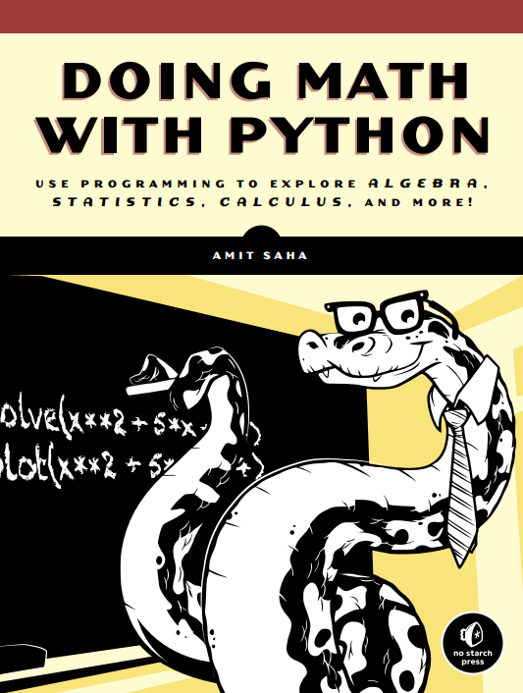

Created By: Ibrahim Qahtan
Supervisor: Assist. Prof. Dr. Miran Taha

Executive Summary: From Algebraic Solutions to Data Visualization
The segment of "Doing Math with Python" spanning pages 20 through 45 serves as a critical bridge, guiding the reader from purely computational problem-solving to the essential practice of data visualization. This section effectively demonstrates Python's dual utility as both a robust calculator for complex algebraic problems and a dynamic tool for visual data interpretation. The core pedagogical achievement of these pages is the seamless transition from abstract mathematical concepts to their tangible, visual representation, thereby empowering the reader to not only find answers but also to discover and communicate the stories hidden within data.
Key Concepts and Skills Developed
- Advanced Algebraic Problem-Solving: The section commences by extending the reader's programming skills to solve quadratic equations. A significant step is taken by introducing the cmath library to handle equations that yield complex number solutions. This module reinforces the concept that programming can elegantly manage mathematical complexities that are often cumbersome to solve by hand, providing a complete and robust tool for algebraic exploration.
- Introduction to Data Visualization: The primary focus shifts to the introduction of matplotlib, a cornerstone library for plotting in Python. The text methodically lays the groundwork, starting with the foundational principles of the Cartesian coordinate plane. It ensures the reader has a firm grasp of how x and y coordinates are used to plot points before moving on to creating simple graphs. This foundational approach is crucial for building confidence and ensuring a deep understanding of visualization mechanics.
- Practical Application and Customization: The reader is then guided through the practical aspects of creating and enhancing visual plots. The text covers essential techniques such as:
  - Plotting Data Series: Using lists to plot multiple points and create continuous lines.
  - Customization for Clarity: Adding titles, axis labels (x and y), and custom colors to graphs. This emphasizes the importance of creating plots that are not only accurate but also easily interpretable by a wider audience.
  - Real-World Data Application: A key feature of this section is the application of these skills to a real-world dataset—the annual average temperatures of New York City. This example masterfully illustrates how data visualization can be used to analyze trends, compare different data series, and derive meaningful insights from raw numbers.
- Output and Dissemination: Finally, the chapter addresses the practical need to save the generated plots. By teaching the reader how to save their graphs to files, the book prepares them for real-world scenarios where visualizations must be incorporated into reports, presentations, or other documents.
Conclusion
In conclusion, pages 20-45 of the text mark a pivotal point in the reader's journey. By the end of this section, the user is no longer just a coder who can perform calculations; they have become a nascent data analyst equipped with the fundamental tools to visualize information. The chapter successfully instills the understanding that programming is a powerful ally in the study of mathematics, capable of transforming complex data into clear, insightful, and communicable visual narratives. The skills acquired—solving complex equations, plotting data with matplotlib, and applying these techniques to real-world examples—form a robust foundation for the more advanced topics in statistics and calculus that follow.

